Lab 1: Content Analysis of a Child’s Cartoon Show

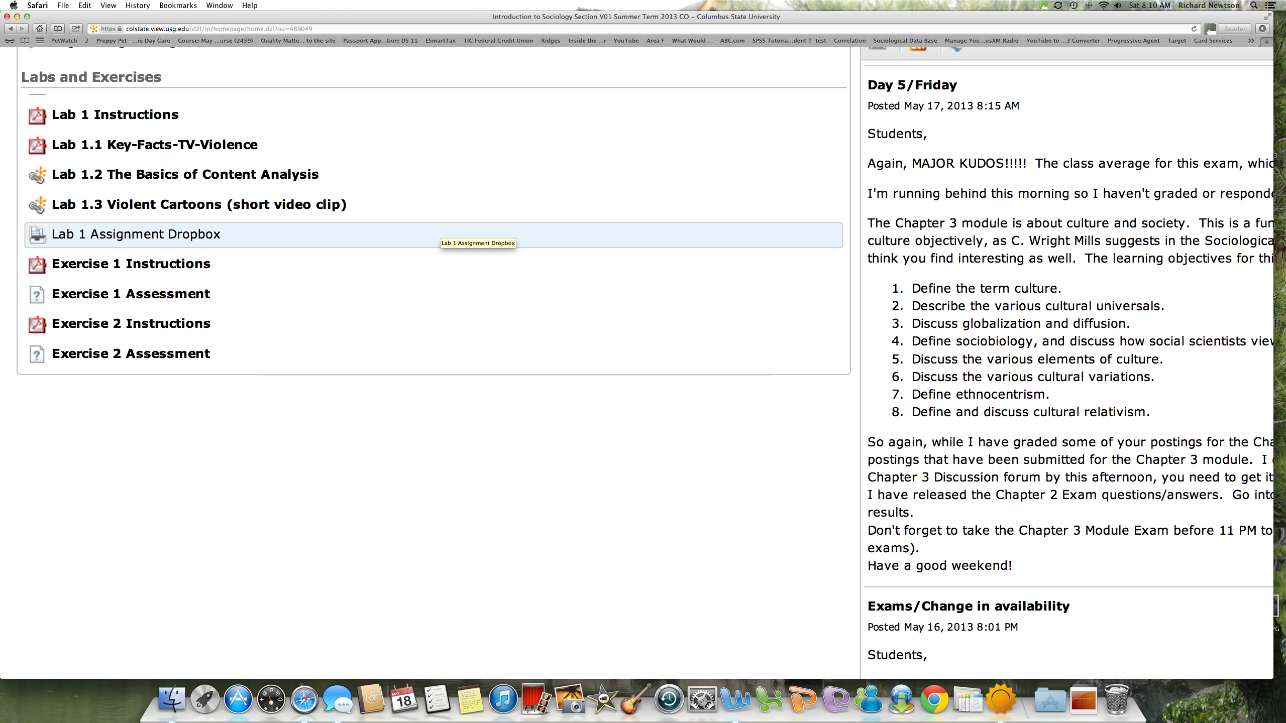

Labs and Exercises will be towards the bottom of the list on the Content Modules page
First, go through the instructions for Lab 1, read the two articles and then watch the short video clip of a violent cartoon. You will create two documents: a Word document for your specific answers to questions I ask, and an Excel document that contains your scoring sheet (information about these items is found in the instructions).

When you have completed both documents, open the Lab 1 Assignment Dropbox.

Step 1. Read the article titled, “Key Facts About TV Violence” found in the learning module.

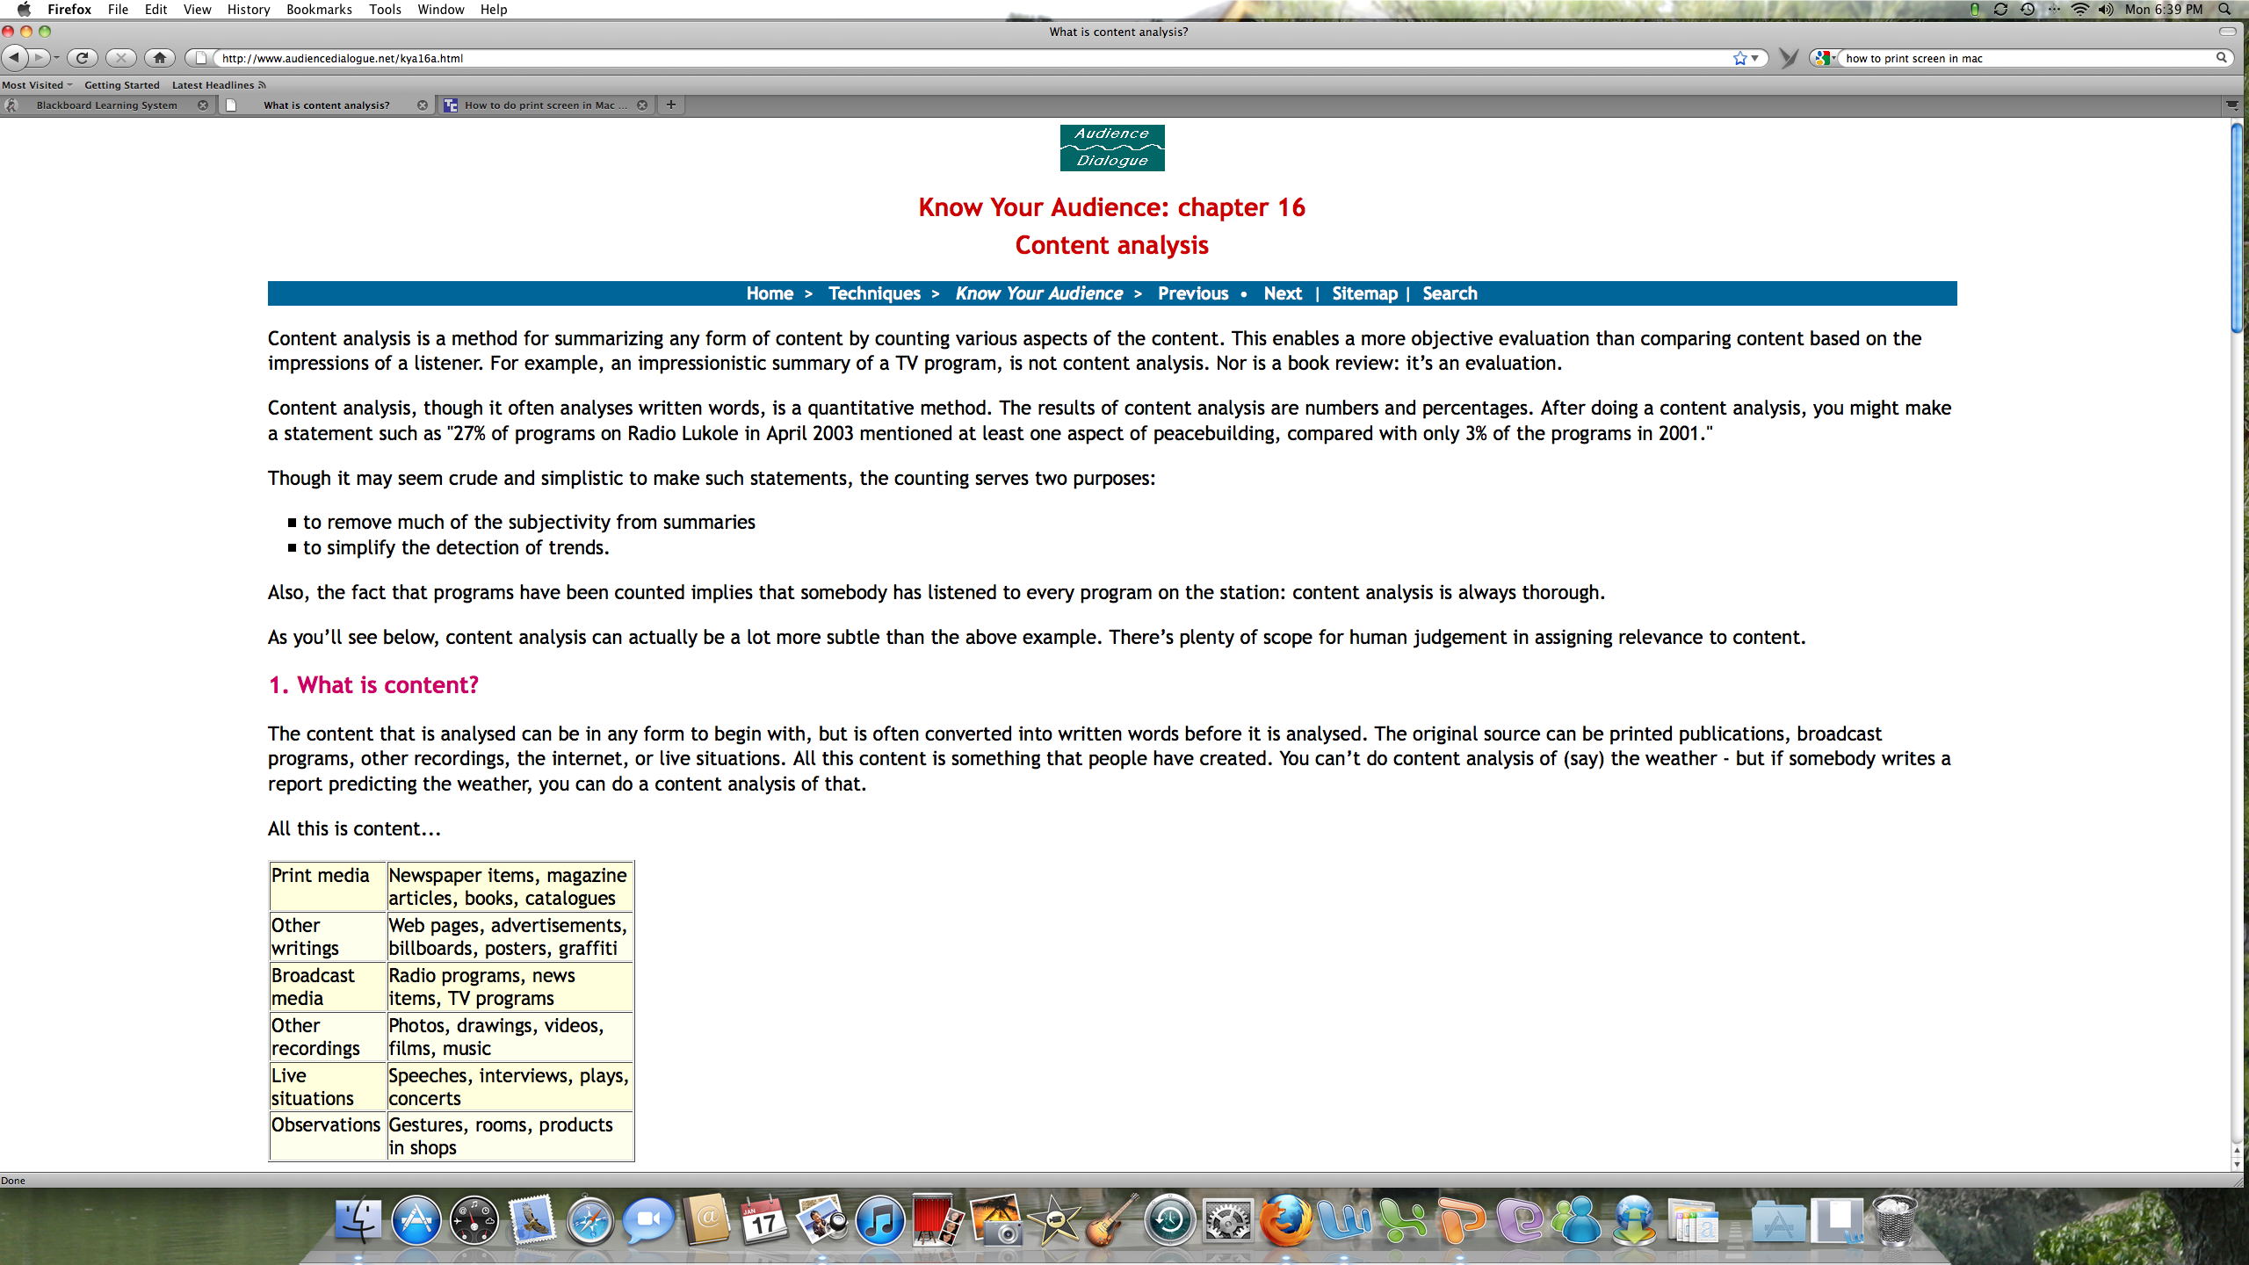
Step 2. Content analysis is the research tool used to collect much of the data reported in the above article on TV violence. Read the article titled, “The Basics of Content Analysis” in the learning module.

Step 3. Watch the short cartoon in the learning module titled, “Violent Cartoon.”

As you watch, count the number of violent acts you see. How many acts of violence did you count? I counted 10 acts. If you counted a different number of violent acts, it’s because we probably define violence differently. How do we resolve this problem? We devise a scoring and/or coding sheet.
Step 4. Critics of television violence research note that media violence experts measure television violence quite differently. George Gerbner of the University of Pennsylvania's Annenberg School for Communication measures most acts of violence equally, whether an accident or intentional. The National Coalition on Television Violence "weighs" violence so a minor act like shoving counts as one-third of an act of violence while murder counts as one and two-thirds an act of violence.¹

Develop your own definition of violence. Keep in mind things like motives (revenge or passion), consequences (death or financial reward), techniques (shoot-outs or fist fights), intentions (to frighten or to kill), etc. Your definitions of violence must be as exhaustive as possible. For instance, pushing, shoving, throwing things, hitting, slapping, etc. And for each of the aforementioned, you will probably have to be even more specific. For instance, pushing. You would want to identify separate acts of pushing with different weights—pushing someone backwards, pushing someone and they fall backward and hit something (like a handrail in an elevator while being monitored on closed-circuit TV), pushing someone and they fall on the floor, etc. Just on this one example I might decide the following weights:

Act | Weight
Pushing someone without risk of injury | .75
Pushing someone with risk of injury | 1.0
Pushing someone with great risk of injury | 2.0

Keep in mind that those things you list on your scoring sheet as acts of violence must agree with your explicitly stated definition of violence—you will lose points if they do not agree.

Step 5. Create your scoring sheet—you can either use Word or Excel. You want to create a scoring sheet that you will have in front of you as you watch your chosen cartoon. The scoring sheet will include all acts defined as violent, time of act (starting from minute one when the show begins), and the victim (e.g., male or female).

At minimum, I would expect your scoring sheet to include these components:

Scoring Sheet Example

Name of Show | When Viewed | Channel | Violent Act Viewed | Time Specific Act Viewed | Victim(s) | Laugh Track—YES or NO | Score
Roadrunner | Sat 9-9:30 AM | Cartoon Network | Pushing with injury | 2’30” | Wile E. Coyote | Yes | 2.0
 |  |  | Hitting | 3’01” | Wile E. Coyote | Yes | 2.0
 |  |  | Dropping an anvil | 3’52” | Wile E. Coyote | Yes | 3.0
Note: One row for each violent act viewed.

Step 6. Choose a Saturday morning cartoon (minimum of 30 minutes) to view. Using the scoring sheet that you constructed, watch your cartoon while recording acts of violence.

Step 7. Finally, write up your results into one coherent paper using Word. Label your answer for each of the following questions. The paper should be organized as follows:

7a: How do you define ‘violence?’
7b. What was the name of the cartoon you watched?
7c: Time and day you watched the show.
7d: What are the shows demographics? Who is the intended audience? For instance, the Cartoon Network shows “Generator Rex” at 9 AM on Saturday mornings. Animation Insider (September 29, 2010) reported, “Generator Rex premiered on Cartoon Network in April 2010, and with it launched the children’s entertainment channel’s renewed guest for young male demographics.” Don’t just give me your guess, do a little research online to support what you write about the intended demographic for the show—cite that research.
7d: Summarize in words your findings (i.e., in thinking about what you watched and recorded in your scoring sheet, offer a summary).
7e: Conclusions. If you were writing this to an audience concerned about children (or adults depending on what you group selected in the way of TV shows) and TV violence, what would your conclusions be to them?

When you are done, you will have two documents: one containing your answers for Questions 7a – 7e (a Word document), and your scoring sheet (either done in Word or preferably in Excel). Open the Lab 1 Assignment Dropbox, and attach both documents.

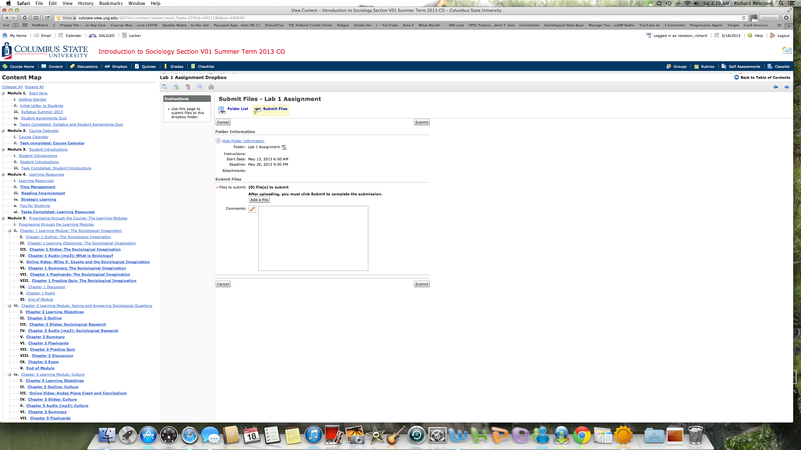

Click “Add a File” to add both of your documents.

After adding both files, click on “Upload.”
Finally, see the Grading Rubric for Lab 1 in this content module. The rurbric is what I will use to grade your submission.

